# **Apache Kafka – Twitter Streaming**



Apache Kafka is a streaming message platform. It is a publish-subscribe based durable messaging system. Kafka is designed to be high performance, highly available, and redundant. It is used to collect, process, store, and integrate data at scale. A messaging system sends messages between processes, applications, and servers.

Use cases for Apache Kafka:

* Stream Processing
* Messaging
* Website Activity Tracking
* Log aggregation
* Event Sourcing
* Application health monitoring

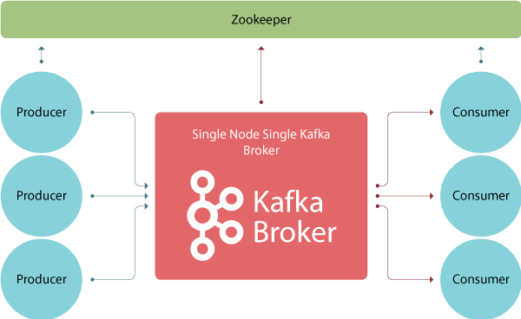

These are four main parts in a Kafka system:

# **Broker**: Handles all requests from clients (producer, consumer and metadata) and keeps data replicated within the cluster. There can be one or more brokers in a cluster

# **Zookeeper**: Keeps track of status of the Kafka clusters (brokers, topics, users)

# **Producer**: Sends records to a broker

# **Consumer**: Consumes batches of records from the broker

# Setup

**Prerequisites:**

1. Installing Oracle Virtual VM Box

**Specifications:**

* 4 GB RAM
* 40 GB Hard Drive
* Downloading ubuntu iso file

**Requirements:**

1. **Installing Ubuntu Guest Edition**

**sudo apt install build-essential dkms linux-headers-$(uname -r)**

* Able to copy/paste the contents easily
* Full screen mode available
* Certain in-built headers/packages available for additional functionalities

1. **Installing Python**

Installing the latest version of Python

**sudo apt install python3**

**sudo apt install python3-pip**

1. **Installing AWS CLI**

AWS CLI helps to access multiple AWS services and functionalities from the command line.

sudo apt install curl

curl "https://awscli.amazonaws.com/awscli-exe-linux-x86_64.zip" -o "awscliv2.zip"

unzip awscliv2.zip

sudo ./aws/install

/usr/local/bin/aws --version

1. **Connecting with AWS**

Connecting the server with AWS account by entering the Access and Secret keys

aws configure

aws s3 ls

1. **Installing Java jdk**

Java jdk is required for starting the Kafka broker and services

sudo apt update

sudo apt list

sudo apt install default-jre

sudo apt install default-jdk

javac --version

1. **Installing Pycharm in Ubuntu**

# Steps for Kafka

1. **Installing Kafka**

Download Apache Kafka from [here](https://kafka.apache.org/downloads)

Unzip Kafka binaries by using tar -xzvf

pip3 install kafka-python

1. **Starting the Zookeeper service and Kafka broker**

**Navigate to the directory where the downloaded files are unzipped and start the Zookeeper service:**

bin/zookeeper-server-start.sh config/zookeeper.properties

**Start the Kafka broker in a new terminal**

bin/kafka-server-start.sh config/server.properties

# Twitter Streaming

**Collecting real time sampled tweets from** [**Twitter**](https://github.com/holladileep/CSYE7245-Spring2021-Labs/blob/main/kafka/twitter.com) **and publishing them to our Kafka Broker**

1. **producer.py**

Running the script **producer.py** for generating sample events

1. **consumer.py**

Running the script **consumer.py** to consume the events published by the producer.

1. **twitter-stream.py**

Using the twitter-stream.py script to fetch tweets from Twitter's API in real-time.

We need to enter our BEARER_TOKEN in the twitter-stream.py script.

Tweets are published to the Kafka Broker.

On running **consumer.py** again, we can see all the published events that are collected by the consumer.